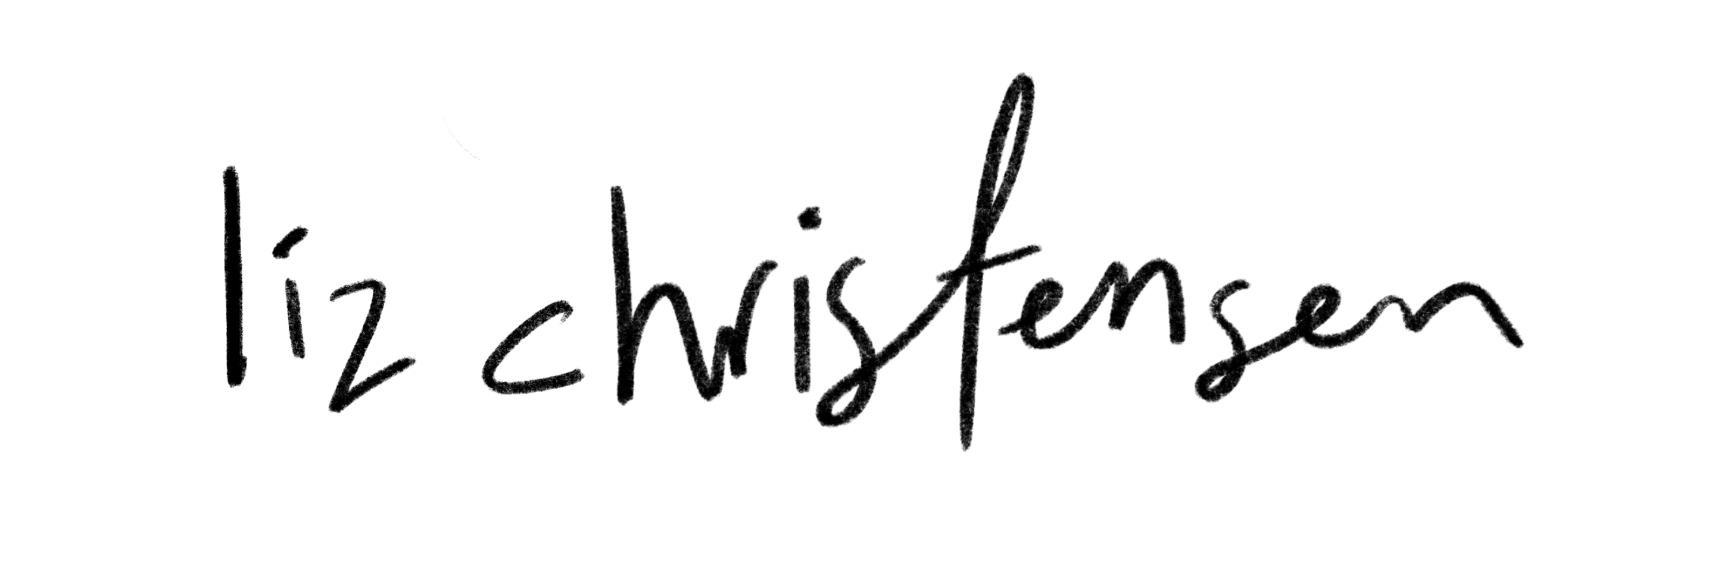

Liz Christensen is an Alberta-based Pop/Country Artist influenced by artists such as Taylor Swift, Sheryl Crow and Stevie Nicks.
Her new single, “Ruined Roses" (May 2023) is a conversational confessional about a love that went wrong. Penned over a zoom write with Brettyn Rose and Lydia Sutherland, “Ruined Roses” hits where it hurts.“The moment we wrote the hook I was just so mesmerized. To me it so well represents the disillusionment of a love that turns to heartbreak.”
Liz’s previous single, “Small Town” is a heartfelt ballad about growing up and the loss and nostalgia of youth. "I Really Like You" (July 2021) is a cotton candy pop bop about catching feelings for someone. Meanwhile, her singles “Summertime” (2020) and “Different Shoulders” (2020) embody more of a rootsy, storyteller vibe. Liz released her debut single “Fences” (2018) and was a winner of 96.5 CKFM’s (Olds, Alberta) Star Search (2018).

